LAB PROGRAMS

NAME: M.SAI HARSHITHA
REG.NO: 192424408
COURSE CODE: DSA0606
COURSE NAME: DATA HANDLING AND VISUALIZATION

SET 8 – Survey Response Analysis
- Create a Grouped Bar Chart
Procedure:
- Open Tableau Desktop.
- Connect to the Survey Response dataset.
- Open a new worksheet.
- Drag Survey ID to Columns.
- Drag Question 1 to Rows.
- Convert Question 1 to Measure → Count (if required).
- Click Show Me and select Side-by-Side Bars (Grouped Bar Chart).
- Drag Question 1 to Colour.
- Drag Count of Question 1 to Label.
- Sort the chart if required.
- Rename the worksheet as Grouped Bar Chart.
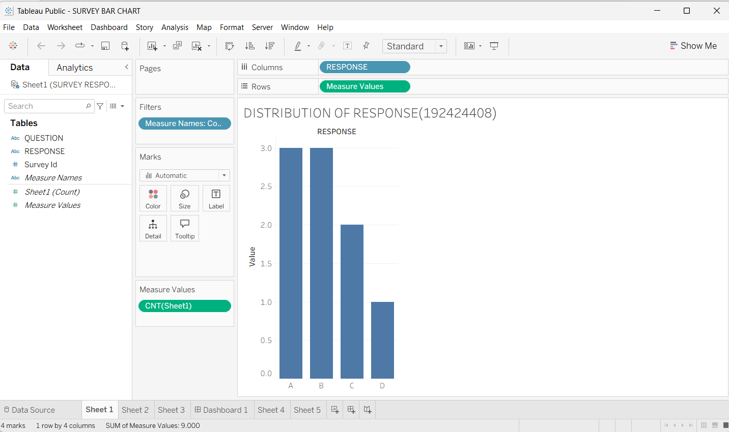
2.Create a Stacked Bar Chart
Procedure
- Create a new worksheet.
- Drag Survey ID to Columns.
- Drag Measure Values to Rows.
- Drag Measure Names to Color.
- Filter Measure Names to include:
  - Question 1
  - Question 2
  - Question 3
- From Show Me, select Stacked Bars.
- Enable Show Mark Labels.
- Rename the worksheet as Stacked Bar Chart.
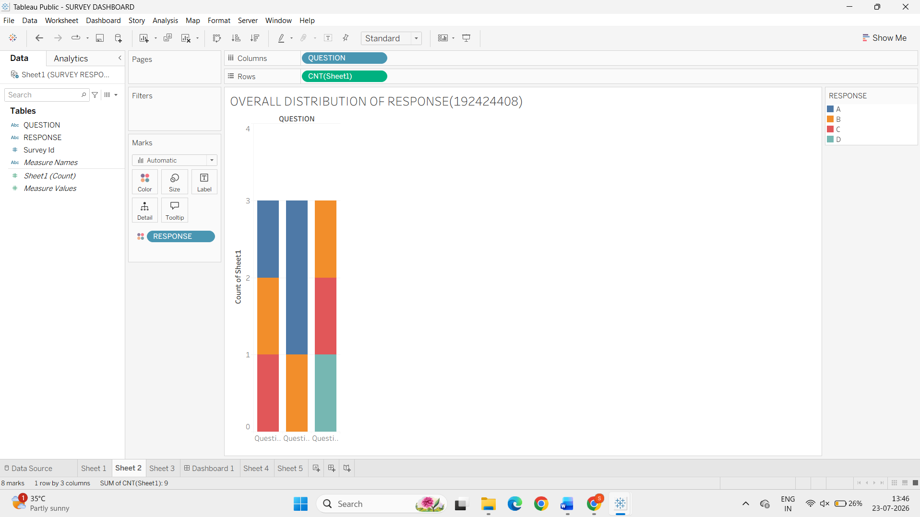

3.Build a Table
Procedure
- Create a new worksheet.
- Drag Survey ID to Rows.
- Drag Question 1, Question 2, and Question 3 to Text.
- Rename column headers if necessary.
- Rename the worksheet as Survey Response Table.
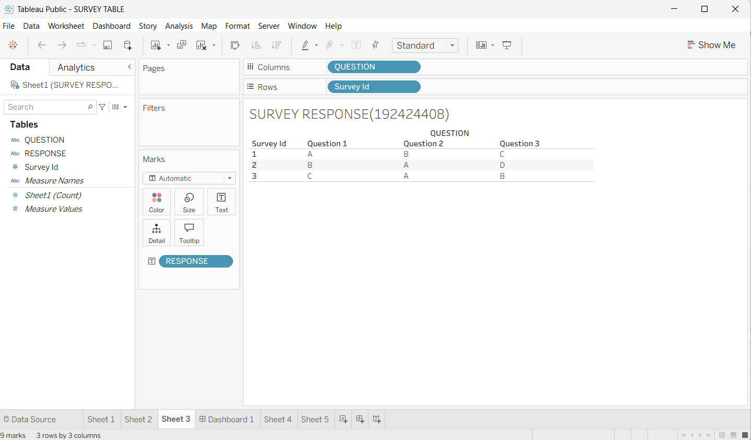

4.Create Dashboard
Procedure
- Click New Dashboard.
- Set dashboard size to Automatic.
- Drag:
  - Grouped Bar Chart
  - Stacked Bar Chart
  - Survey Response Table
- Arrange them neatly.
- Click the drop-down on the Grouped Bar Chart and select Use as Filter.
- Give the dashboard title:
Survey Response Analysis Dashboard.
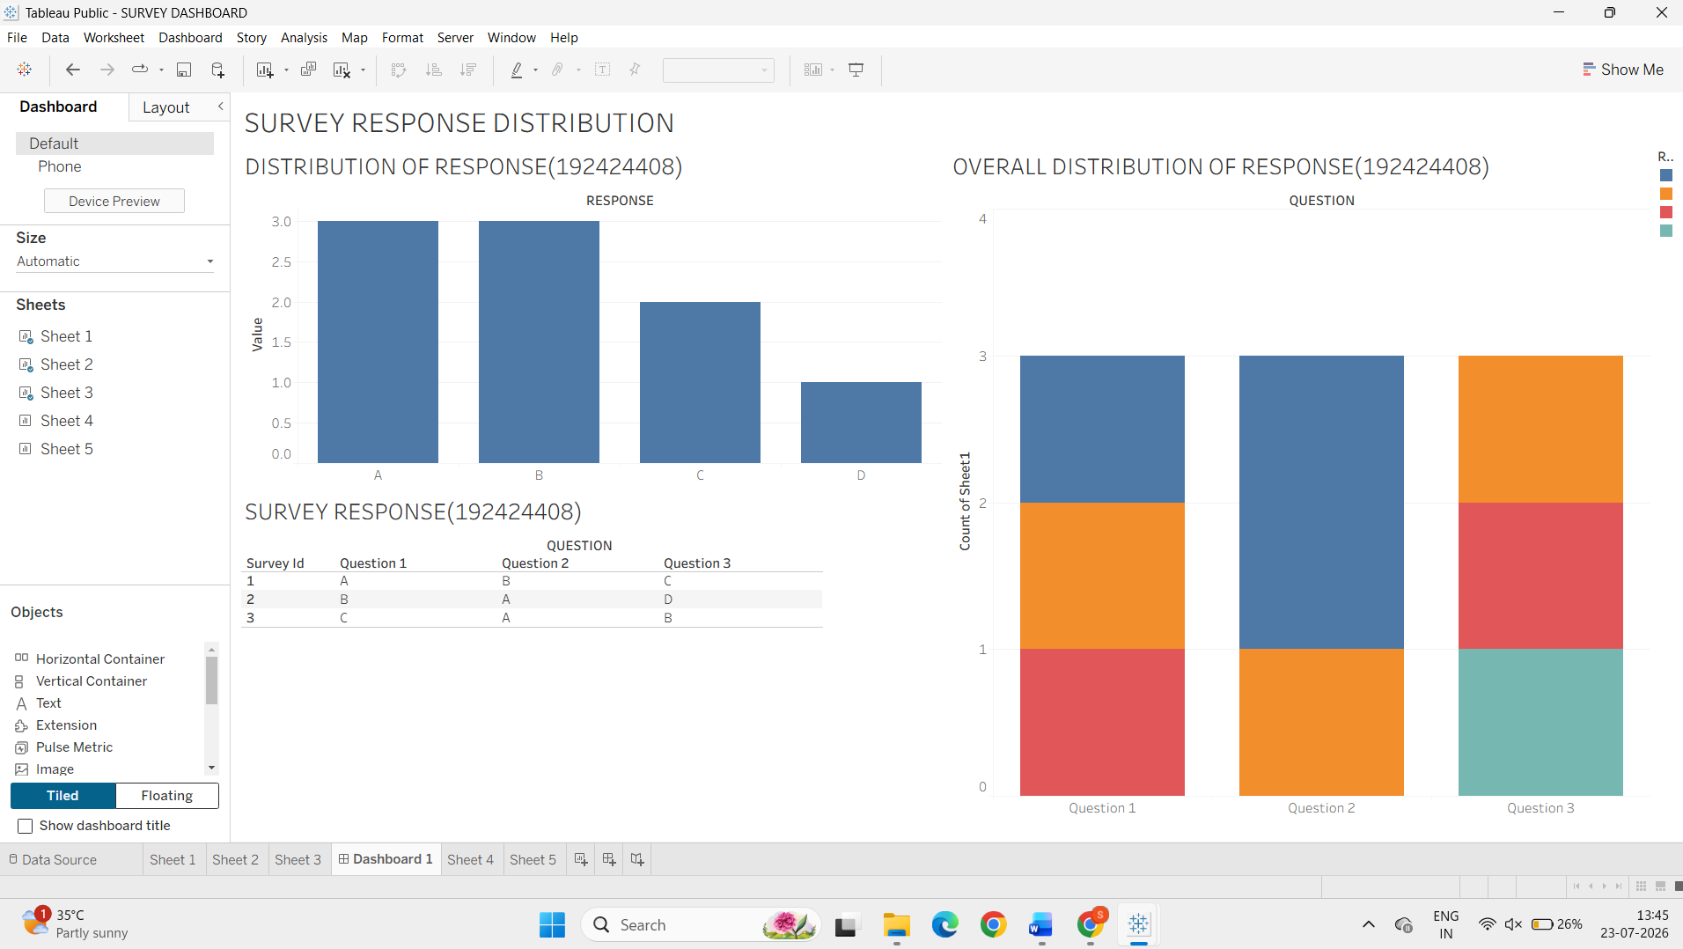

SET 9 – Product Category Analysis
1. Create a Funnel Chart
Procedure:
- Open a new worksheet.

- Drag Category to Rows.
- Drag Sales to Columns.
- Sort the values in Descending order.
- Change the Marks type to Bar.
- Drag Sales to Size.
- Drag Category and Sales to Label.
- Format the bars to resemble a funnel.
- Rename the worksheet as Sales Funnel Chart.

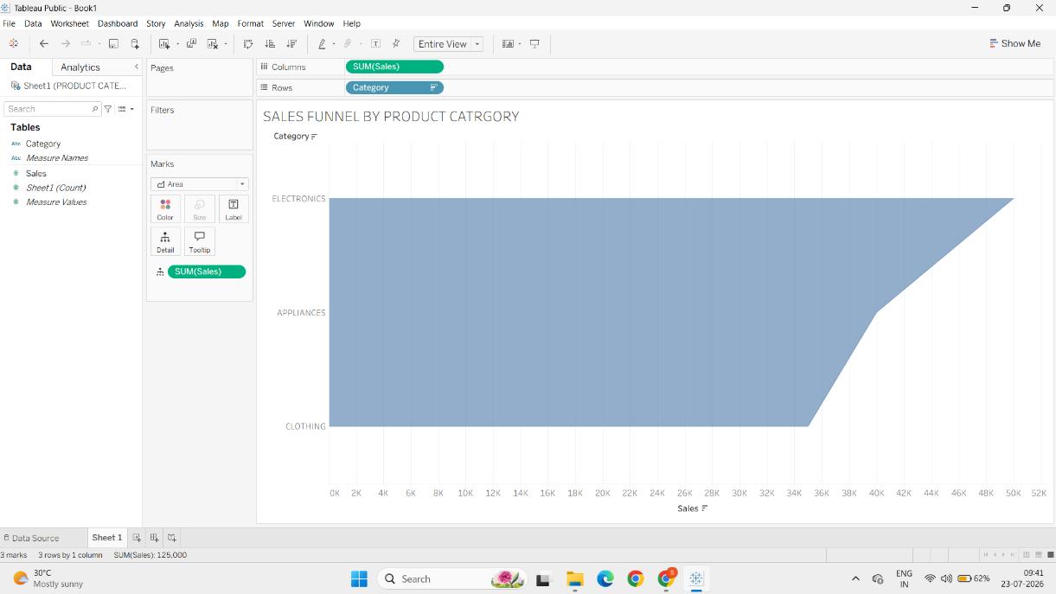

2. Create a Table
Procedure:
- Open a new worksheet.
- Drag Category to Rows.
- Drag Sales to Text.
- Display the sales values.
- Rename the worksheet as Product Sales Table.
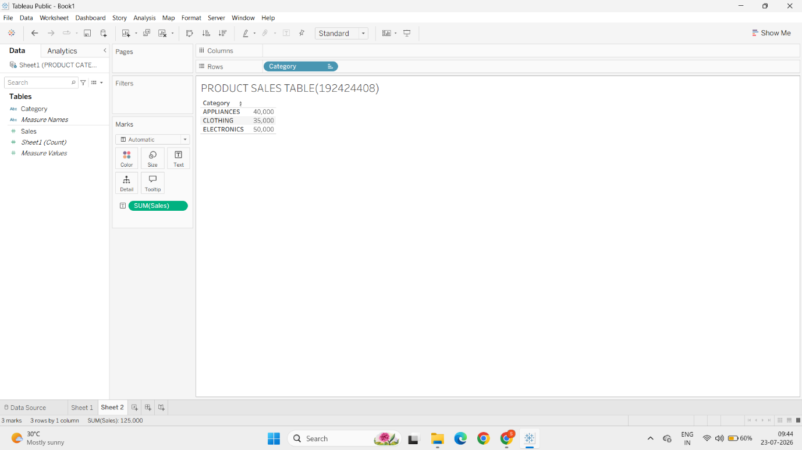

4.Create a Pie Chart
Procedure:
- Open a new worksheet.
- Drag Category to Color.
- Drag Sales to Angle.
- Drag Category to Label.
- Drag Sales to Label.
- Click Show Mark Labels.
- Rename the worksheet as Sales Distribution Pie Chart

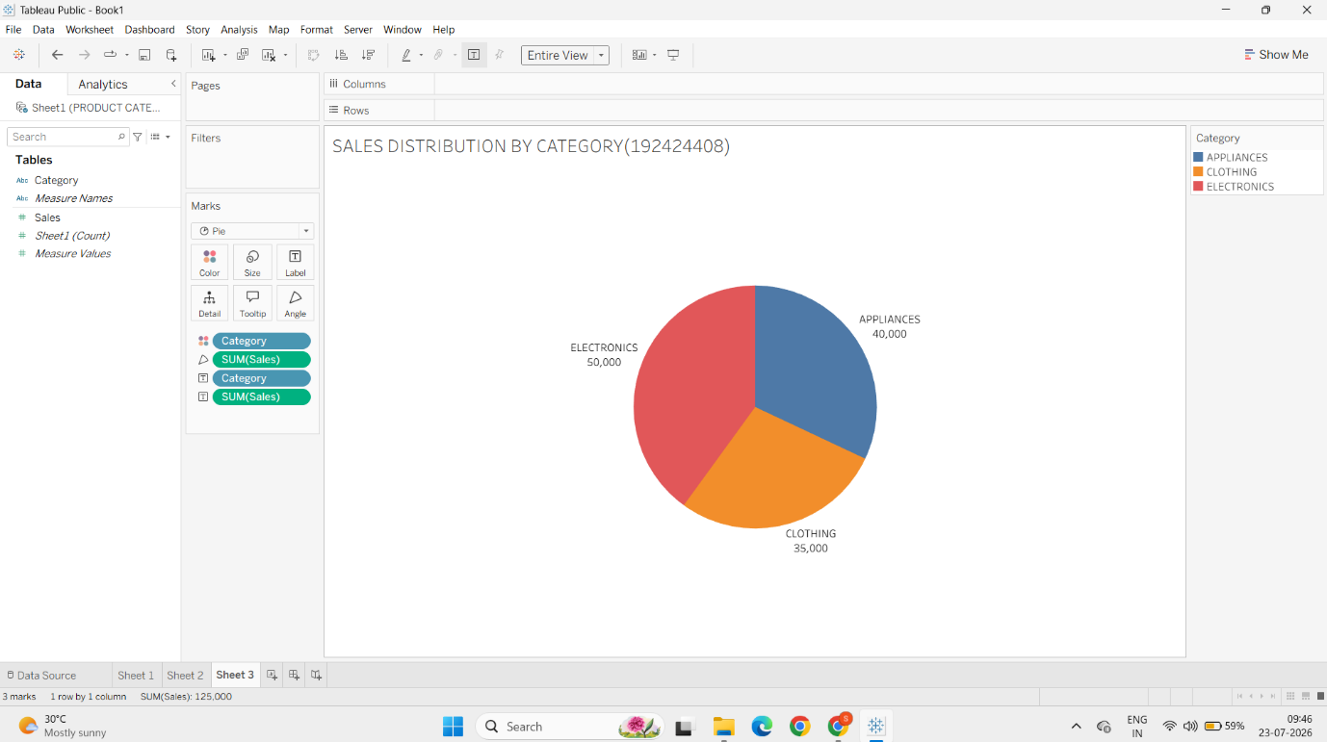

3. Create Dashboard
Procedure
- Create a new dashboard.
- Drag:
  - Funnel Chart
  - Pie Chart
  - Product Sales Table
- Arrange them neatly.
- Enable Use as Filter on the Pie Chart.
- Rename the dashboard as:
Product Category Analysis Dashboard.

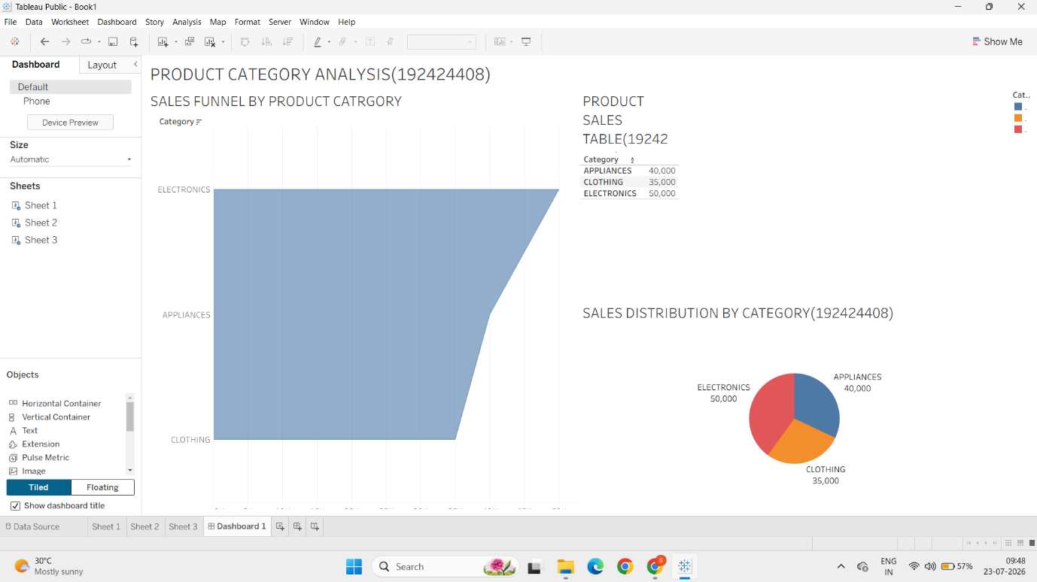
SET 10 – Geographic Data
1.Create a Map Chart
Procedure
- Open Tableau and connect to the Geographic dataset.
- Ensure the City field has Geographic Role → City.
- Double-click City to generate the map.
- Drag Population to Size.
- Drag City to Label.
- Drag Population to Colour.
- Rename the worksheet as Geographic Map.
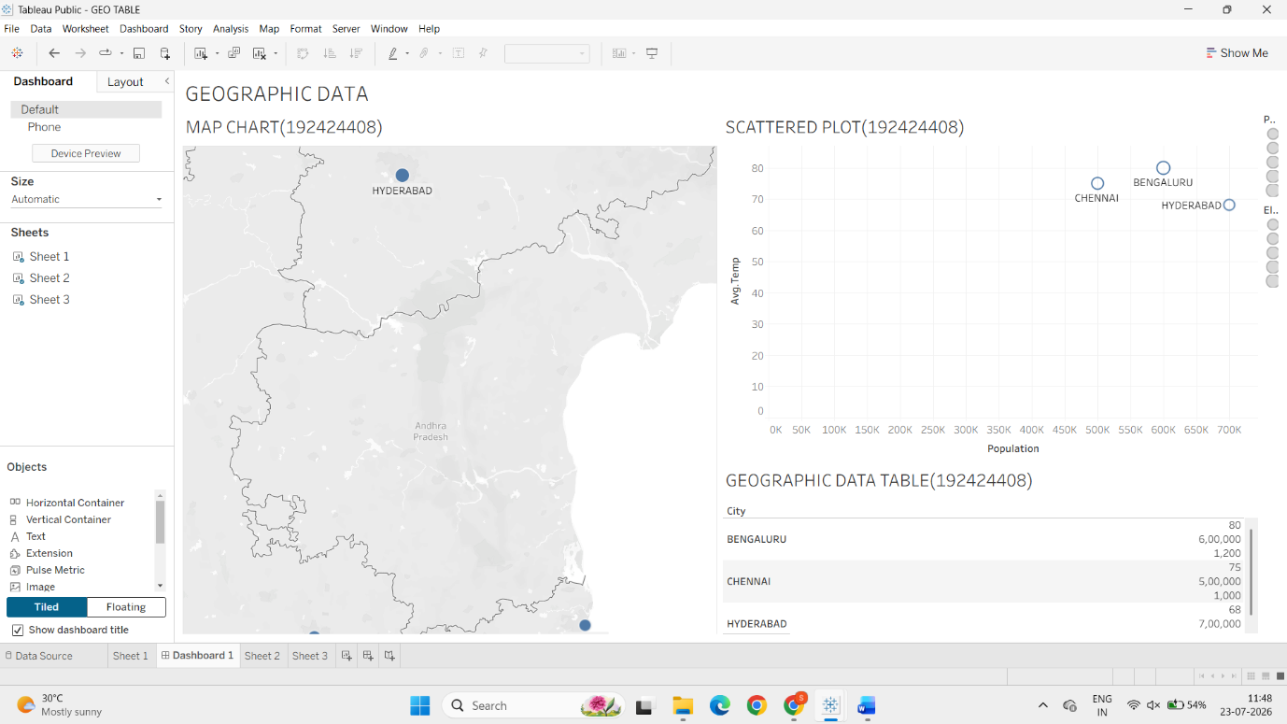

2.Create a Scatter Plot
Procedure
- Open a new worksheet.
- Drag Population to Columns.
- Drag Average Temperature to Rows.
- Change the Marks type to Circle.
- Drag City to Label.
- Drag Elevation to Size .
- Rename the worksheet as Population vs Temperature Scatter Plot.
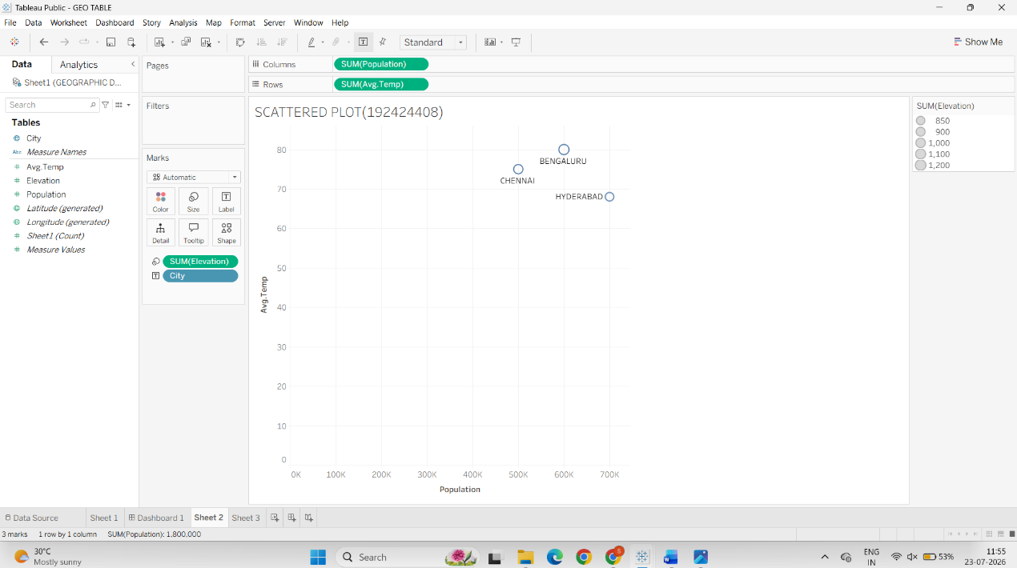

3. Build a Table
Procedure :
- Create a new worksheet.
- Drag City to Rows.
- Drag Population, Average Temperature, and Elevation to Text.
- Rename the worksheet as Geographic Data Table.
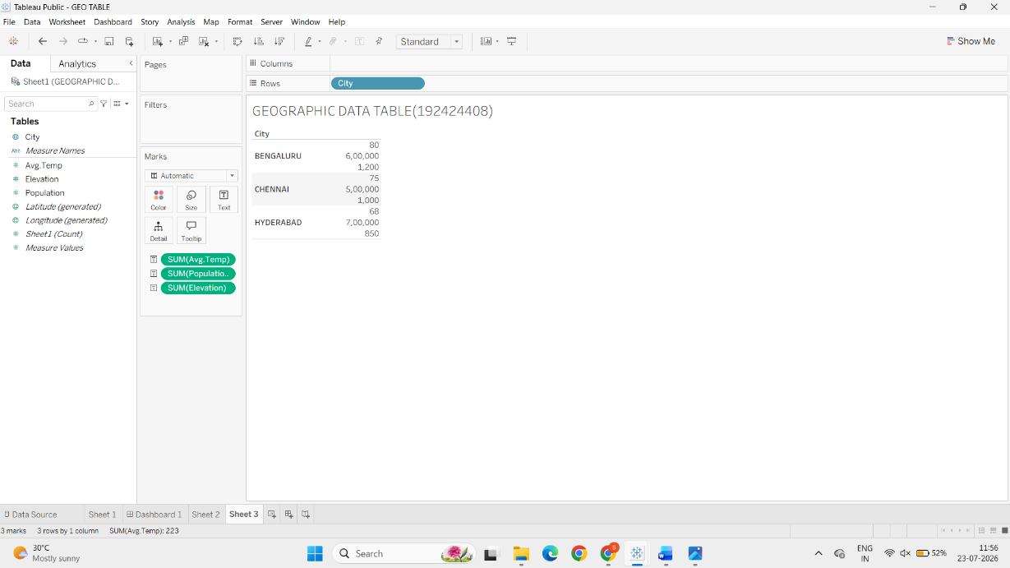

4.Create Dashboard
Procedure :
- Create a new dashboard.
- Drag:
  - Geographic Map
  - Scatter Plot
  - Geographic Data Table
- Arrange them appropriately.
- Enable Use as Filter on the Map.
- Rename the dashboard as:
Geographic Data Dashboard




